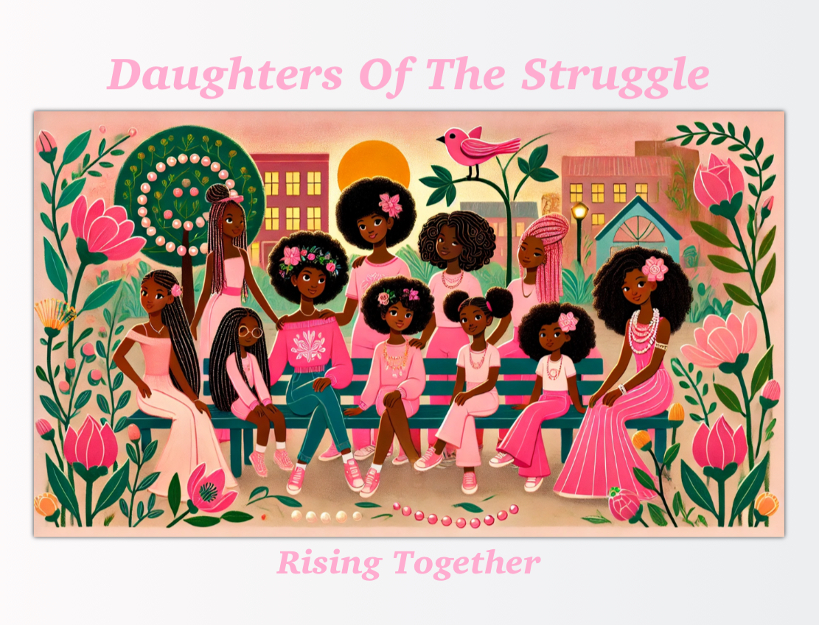

Daughters Of The Struggle– ***Membership Application Form***  
  
**Personal Information**  
Full Name: ______________________________________  
Date of Birth: ______________________________________  
Grade Level (Circle One): Elementary / Middle School  
School Name: ______________________________________  
Home Address: ______________________________________  
City: ______________________________________  
State: ______________________________________  
Zip Code: ______________________________________  
Phone Number: ______________________________________  
Email Address (if applicable): ______________________________________  
  
**Parent/Guardian Information**  
Parent/Guardian Full Name: ______________________________________  
Relationship to Applicant: ______________________________________  
Phone Number: ______________________________________  
Email Address: ______________________________________  
Emergency Contact Name: ______________________________________  
Emergency Contact Phone Number: ______________________________________  
  
**Medical Information**  
Do you have any medical conditions or allergies we should be aware of?  
Yes / No (Circle One)  
If yes, please explain: ______________________________________  
  
**Interests and Goals**  
1. Why are you interested in joining [Organization Name]?  
  
  
2. What do you hope to achieve by being a part of this organization?  
  
  
3. What activities or topics are you most excited about? (Check all that apply)  
[ ] Academic Support / College Preparation  
[ ] Community Service  
[ ] Mental Health & Well-being  
[ ] Sisterhood & Leadership  
[ ] Policing and Community Relations  
[ ] Gun Violence Prevention  
[ ] Other: ________________________

4. What are your personal goals for the next year?  
  
  
  
**Parent/Guardian Agreement**  
As a parent/guardian, I understand the commitment involved in my child’s participation in this program and agree to encourage her involvement in the activities. I am also aware that the organization may contact me for further information or support.  
  
Parent/Guardian Signature: ______________________________________  
Date: ______________________________________  
  
Applicant’s Commitment  
By signing below, I agree to actively participate in the activities and programs provided by [Organization Name] and commit to following the organization’s rules and guidelines.  
  
Applicant’s Signature: ______________________________________  
Date: ______________________________________  
  
**Submission Instructions**  
  
Please return this completed application to madottie@daughters-of-the-struggle.org

If you have any questions, contact us at 708.512.DOTS (3687)