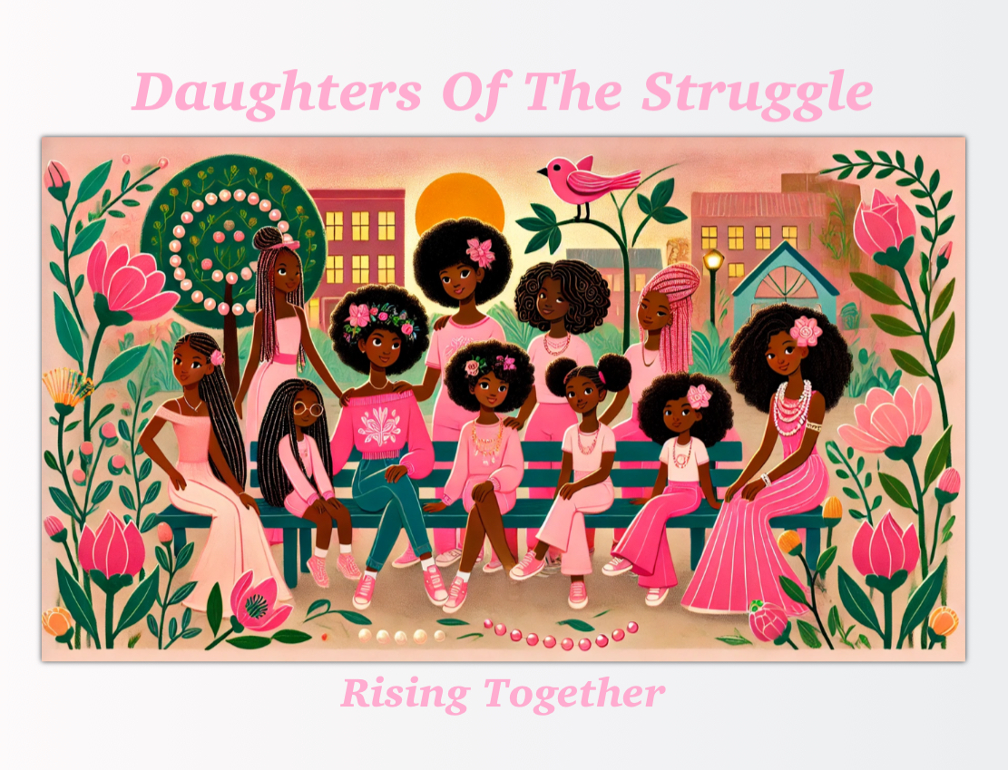

Daughters Of The Struggle– ***Mentorship Program Application***  
  
**Personal Information**  
Full Name: ______________________________________  
Gender: ______________________________________  
Date of Birth: ______________________________________  
Phone Number: ______________________________________  
Email Address: ______________________________________  
Home Address: ______________________________________  
City: ______________________________________  
State: ______________________________________  
Zip Code: ______________________________________  
  
**Occupation & Education**  
Current Job Title: ______________________________________  
Company/Organization: ______________________________________  
Highest Level of Education Completed: ______________________________________  
Field of Study: ______________________________________  
  
**Mentorship Interests**  
Why do you want to be a mentor for young girls in this program?  
  
What skills, knowledge, or experiences would you like to share with the girls?  
  
What are you hoping to gain from being a mentor in this program?  
  
What areas of mentorship are you most interested in? (Check all that apply)  
[ ] Academic Support  
[ ] Career Development  
[ ] Leadership & Confidence Building  
[ ] Emotional Support & Mental Health  
[ ] Personal Development  
[ ] Community Engagement & Volunteering  
[ ] Other (please specify): ______________________  
  
**Availability**  
How often would you be available to meet with your mentee(s)?  
[ ] Weekly  
[ ] Bi-weekly  
[ ] Monthly  
[ ] Other (please specify): ______________________  
  
What times of day are you most available?  
[ ] Morning  
[ ] Afternoon  
[ ] Evening  
  
**Background and Experience**  
Do you have any previous mentoring experience?  
Yes / No (Circle One)  
If yes, please explain:  
  
Do you have any experience working with youth, especially girls?  
Yes / No (Circle One)  
If yes, please explain:  
  
**References**  
Please provide at least two references (one professional, one personal).  
Reference 1:  
Name: ______________________________________  
Relationship to You: ______________________________________  
Phone Number: ______________________________________  
Email Address: ______________________________________  
  
Reference 2:  
Name: ______________________________________  
Relationship to You: ______________________________________  
Phone Number: ______________________________________  
Email Address: ______________________________________  
  
**Background Check & Consent**  
As a mentor, I understand the importance of ensuring a safe and positive environment for the girls in this program. I agree to undergo a background check and provide any necessary documentation required by [Organization Name].  
  
[ ] Yes, I agree to the background check.  
[ ] No, I do not agree to the background check (applicant will not be eligible to proceed).  
  
**Mentor Agreement**  
By signing below, I acknowledge the responsibilities of being a mentor, including the need for confidentiality, professionalism, and a commitment to providing positive guidance and support. I agree to act as a role model for the girls in this program, encouraging their personal growth and success.  
  
Mentor Signature: ______________________________________  
Date: ______________________________________  
  
**Submission Instructions**  
  
Please return this completed form to [madottie@daughters-of-the-struggle.org](mailto:madottie@daughters-of-the-struggle.org)

For any questions, contact us at [708.512.DOTS (3687)